**Assessment**



**I213-Dynamic Web Solutions**

**Assessment One (Assignment)**

|  |  |  |
| --- | --- | --- |
| **Due Date**  Thursday - 8th August 2019 | **Faculty**  Humanities and Business | |
| **Due Time**  1pm. In class marking | **School**  Business and ICT | |
| **Weighting**  25% | **Programme**  Bachelor of Information and Communications Technology (Applied) | |
| **Submission Method**  Moodle online upload of the documentation and website.  Present prototype to lecturer in class. | **Learning Outcomes Assessed**   * Design and document a Web Application | |
| **Conditions**  This is an individual assessment all work must be your own.  To pass this assessment, you may be asked to adequately explain aspects of your assignment to the lecturer. |  | |
| **Lecturer**  Richard Dargie | | **Moderator**  Graeme Richards |

# Assignment Requirements

1. Given the design documentation provided, you must interpret the documentation, and complete the following:

* Construct a Webpage prototype using the components to match as close as possible, the screenshots provided from the following HTML/CSS framework:
  + W3.CSS <https://www.w3schools.com/w3css/default.asp>
  + Use the default colours “black” for backgrounds “white” for text.
* Unless previously discussed with the lecturer, your prototype will be assessed on the Lab computers, so **please test your layouts on these monitors**.
* For all text, use the default font-family but you must apply the Google Fonts “**Roboto**” and “**Courgette**” to the text specified in the Marking Guide.

1. You **must use** *CSS Grid*to create sections of the page layout as per the design documentation requirements provided. **Failure to use this will result in a failed assessment.**
2. You **must use** the three images provided.
3. Consult with the lecturer regarding anything you are unsure of regarding the requirements.

# Assignment Marking Guide

|  |  |
| --- | --- |
| **TOP NAV** |  |
| Width is 100% of page and closely matches colours (background and text) |  |
| Includes 3 buttons positioned as shown in screenshot. Margins, padding and spacing as per screenshot. |  |
| **HEADER** |  |
| Correctly shows background image and closely matches screenshot. |  |
| Includes h1 heading, and uses the Google font “Roboto”. |  |
| Includes paragraph text and has no spelling mistakes. |  |
| Includes background image (header.jpg) and it matches the screenshot provided |  |
| Width is 100% of page and closely matches colour, margins, padding and spacing as per screenshot provided. |  |
| **SEARCH FILTER SECTION** |  |
| CSS Grid applied and matches screenshot. (3 sections see Figure 4). |  |
| Includes the “Stats” text centered in the left section. |  |
| Includes the “Teams” text centered in the right section. |  |
| Includes a central section with button labelled “Position”, an input box (with search button) that matches the screenshot provided. |  |
| Vertical alignment for all text input and buttons matches the screenshot in Figure 10. |  |
| Top and bottom spacing between the top and bottom borders of the *navbar* are consistent for the text, input box, and buttons and matches the screenshot in figure 10. |  |
| Component colours match the screenshot. |  |
| **PLAYERS SECTION** |  |
| CSS Grid applied to mid-section area and matches screenshot. (See Figure 3) |  |
| Has **consistent** grid gap of 1 rem. |  |
| Includes exactly 12 player cards, 6 on top row and 6 on bottom row. |  |
| **PLAYER CARD** |  |
| Displays the entire “player.jpg” image in correct location as per the screenshot provided. |  |
| The “Player” text is bolded and spaced within the card as per the screenshot provided. |  |
| “The “Position” text is and spaced within the card as per the screenshot provided. |  |
| Card content padded and spaced as per the screenshot provided. |  |
| Borders are applied as per the screenshot provided. |  |
| **MENU SECTION** |  |
| All team names are present and in the correct alphabetical order. |  |
| All team names are consistently spaced apart as per the screenshot provided. |  |
| The top name “Argentina” aligns to the top border of the rightmost player card (see Figure 6) |  |
| The bottom name “Wales” aligns to the bottom border of the rightmost player card (see Figure 7) |  |
| The menu names are left aligned to the edge of the menu appearing approximately 1 rem from the rightmost player card border. |  |
| The team names must be hyperlinks with the underline removed. |  |
| **STATS SECTION** |  |
| The “trophy.jpg” image fully appears and is positioned (space as per screenshot) in the correct location |  |
| **FOOTER** |  |
| Your name appears in the footer, and the *font family* “Courgette” is applied (as per screenshot) |  |
| Vertical spacing between text and top and bottom borders is consistently even. |  |
| Border appears 1 rem from the bottom of the players and menu section as per the screenshot provided. |  |
| **DOCUMENTATION** |  |
| The three elements indicated in the Documentation section each have the appropriate properties entered. |  |

**The following is a guide to how the marks will be awarded. Some progress up the grade levels may be given depending on the amount of work produced and its quality (Lecturers discretion).**

**To obtain a C Grade.**

1. You have used CSS Grid for the areas indicated in the screenshots provided.
2. You have used W3.CSS for your components.
3. Met all requirements for the TOP NAV section.
4. Met all requirements for the HEADER section.
5. Met all requirements for the SEARCH FILTER SECTION.
6. Met all requirements for the FOOTER section.
7. Have constructed 3 sections for the STATS, PLAYER SECTION and MENU SECTION.
8. Met all requirements for the STATS SECTION.
9. You have completed the Documentation for the three elements specified
10. Able to correctly answer questions about the assignment if asked.
11. You have made a reasonable attempt (Lecturers discretion).

**To obtain a B Grade.**

1. You have met the requirements for a **C Grade**.
2. Met all requirements for the PLAYER CARD section.
3. Met all requirements for the PLAYERS SECTION.

**To obtain an A Grade.**

1. You have met the requirements for a **B Grade**.
2. Met all requirements for the MENU SECTION.

**To obtain an A+ Grade.**

1. You have met the requirements for an **A grade.**
2. Demonstrate to the lecturer that all content will display, but the STAT SECTION, PLAYER SECTION and MENU SECTION must display on separate rows. ALSO the PLAYER SECTION’s players will display ONLY two players per row when the Webpage is displayed in a device with a resolution less than 1025px (IPad devices and down).

# Assignment Submission

1. Zip (not .rar) the folder with your name on it, and upload to Moodle in the link provided.
2. When asked in class, download your assignment and present it to the lecturer for marking.

### The Proposed Web page

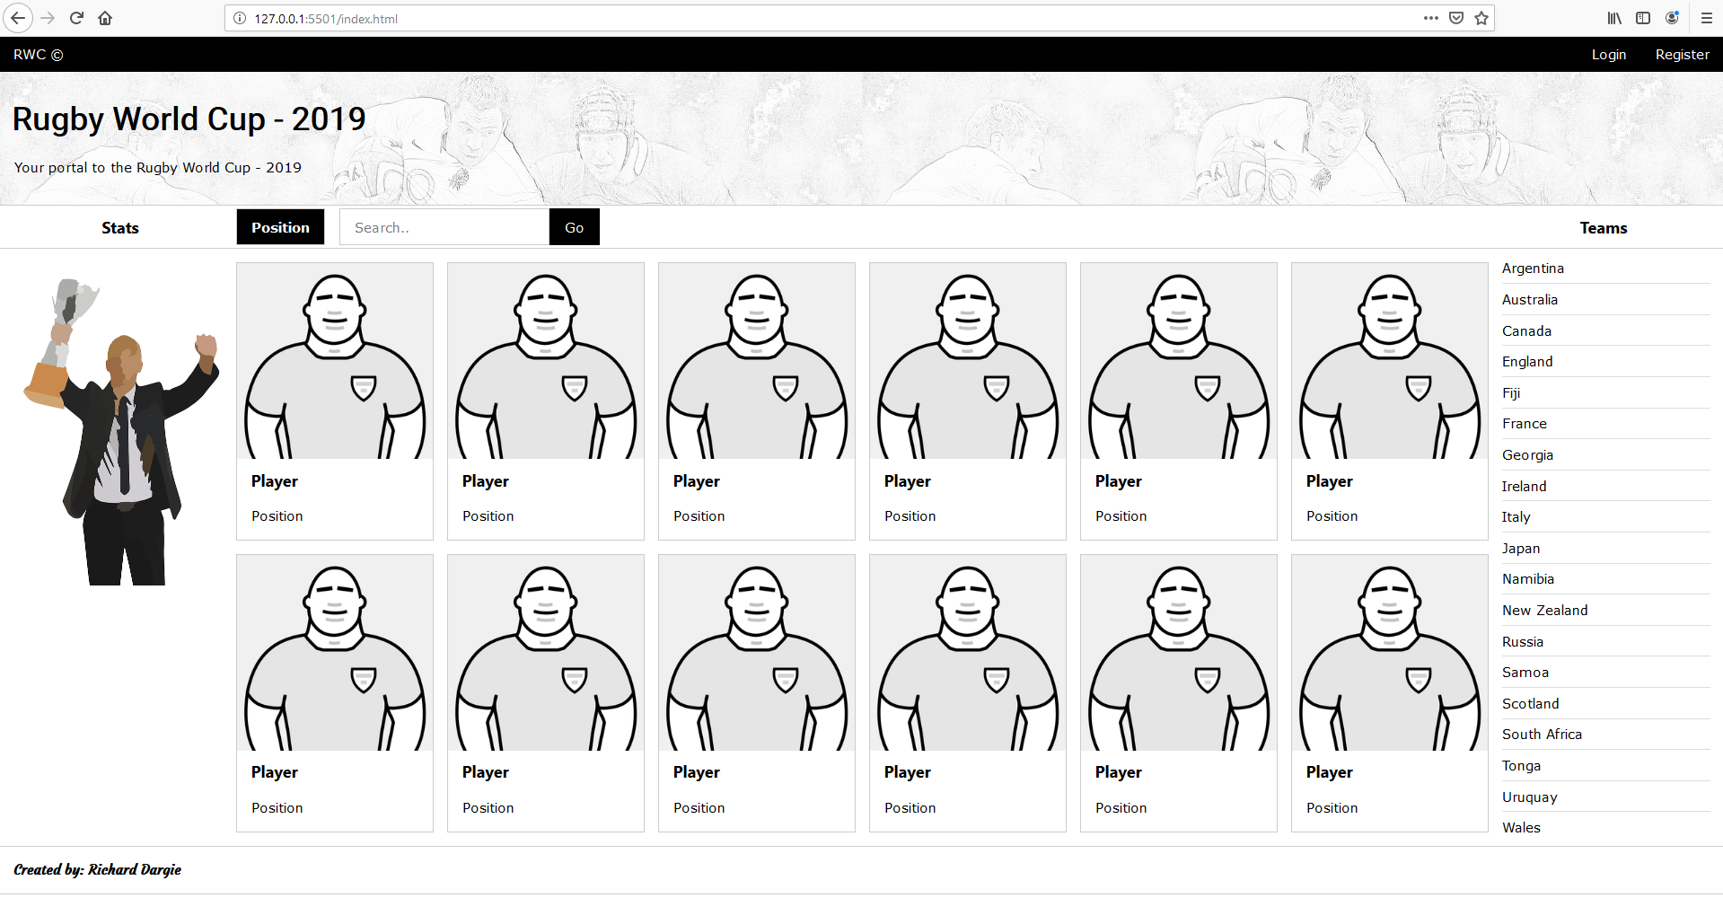

Figure 1 -The Web page when viewed in the Lab computers at full screen (1904p x 941px)

**Main Areas**

top nav



players section

footer

menu section

stats section

search filter section

header

### CSS Grid Screenshot Layouts (1)

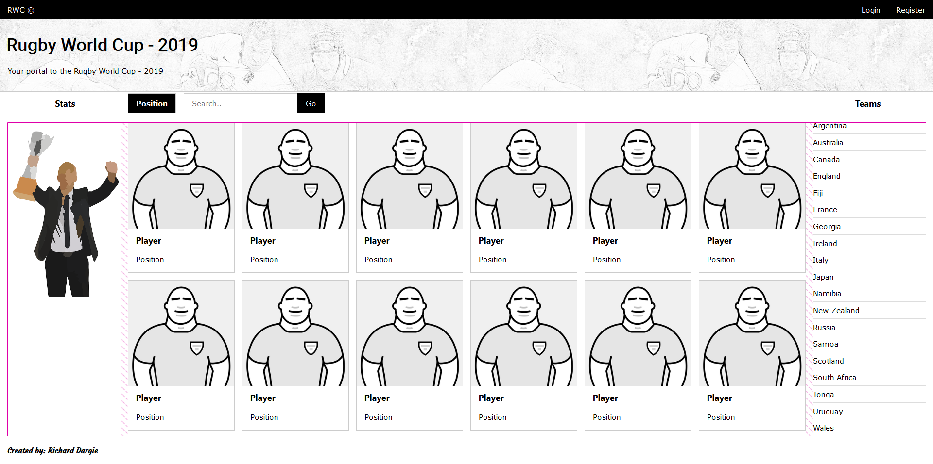

Figure 2-CSS GRID showing the mid-section Grid areas (Grid gap of 1rem)

### CSS Grid Screenshot Layouts (2)

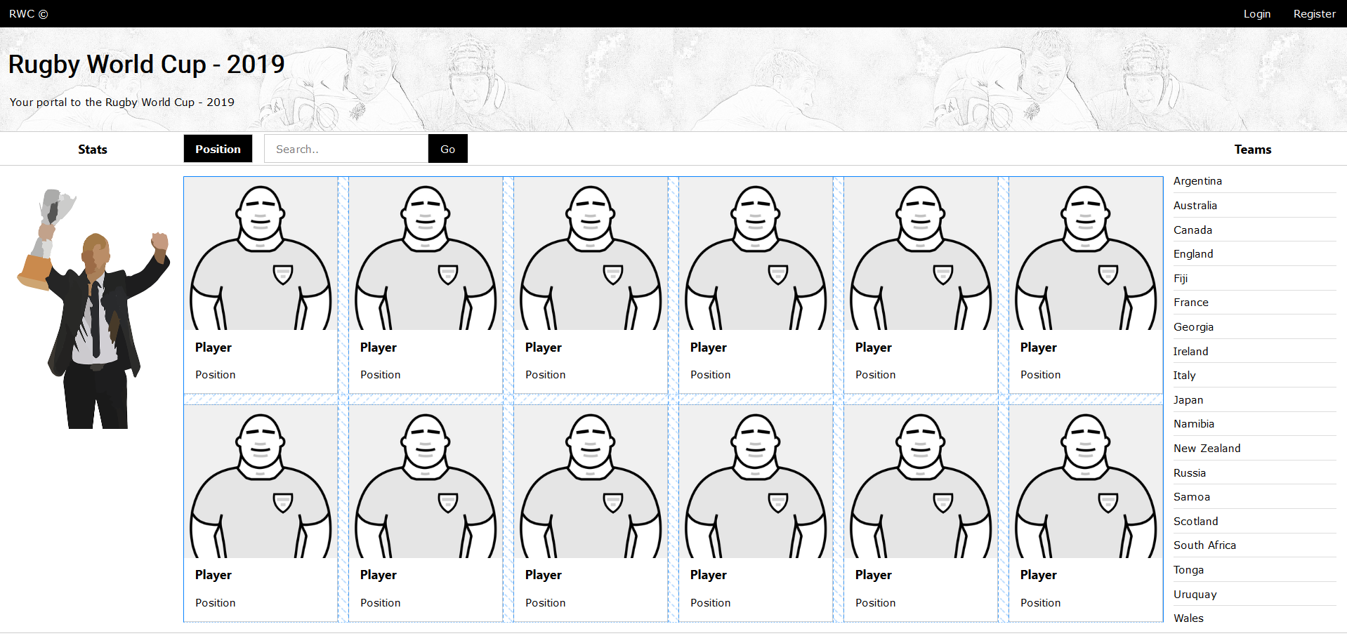

Figure 3- CSSGrid showing the main players sections (grid gap of 1rem)

### CSS Grid Screenshot Layouts (3)

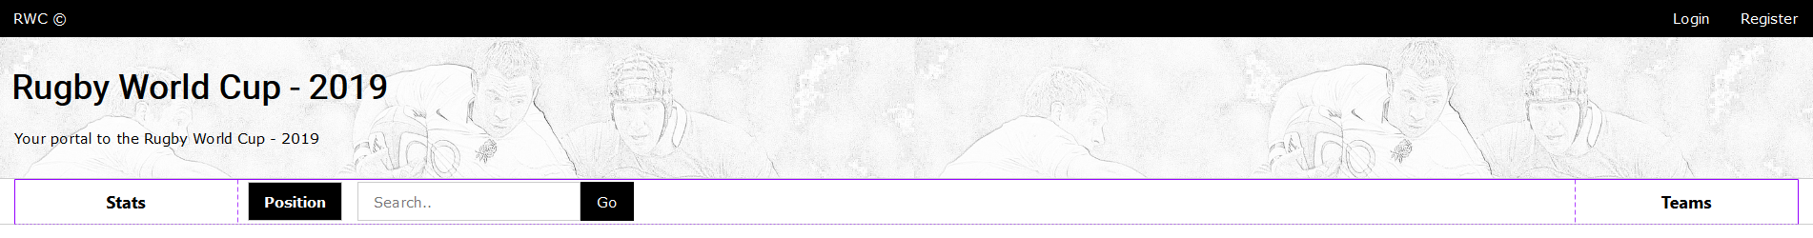

Figure 4-CSS Grid showing the filter navigation areas

### Component Alignments

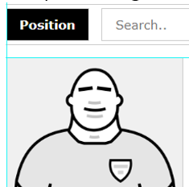

Figure 5 - Showing the left alignment of the Position button and left border of Player card.

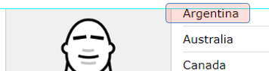

Figure 6-Alignment of the top border of Player card and top of the Team text “Argentina”.

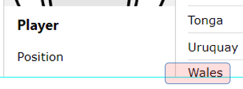

Figure 7-Alignment of the bottom border of Player card and the top of Team text "Wales".



Figure 8 - Showing the horizontal alignment for the search bars; text, buttons and input components.



Figure 9 - Showing the consistent padding between the buttons, input box and the Search bars top and bottom borders.



Figure 10 - Showing the consistent vertical padding between the text and top and bottom borders of the footer

**Documentation (Complete the specifications for the 3 elements shown below)**



|  |  |
| --- | --- |
| **element type** | header |
| **id** | header |
| **class/s** | W3-display-container |
| **width** | 100% |
| **height** | 169px |
| **background url** | “img/header.jpg” |



|  |  |
| --- | --- |
| **element type** | H1 |
| **id** | h1 |
| **class/s** | W3-display-left |
| **font family** | Roboto |
| **font weight** | Blod |
| **font size** | 38px |
| **font colour** | Black |



|  |  |
| --- | --- |
| **element type** | a |
| **id** | a |
| **class/s** | Item18 |
| **href** | # |
| **font family** | Default |
| **list-style-type** | None |
| **text-decoration** | None |